**Geocoder Configuration**

1. **Observation: Geocoder needs two keys to work. A Map Key (Bing or Google) and an Application License Key. To Geocode only one Map Key is required. Important, to create a Google Map Key, you will need a valid credit card. For Bing Map Keys you will need only a valid e-mail address. If you don’t want to provide a credit card, the program will work normally with the Bing Map Key. The Application *License Key* is generated by the Omnitracs Brazil Support team. If you get an Application License Key expiration warning you will need to provide a new one.**
2. To acquire Maps Engine Keys (required to geocode) follow the steps below:
   1. For Bing key, access <https://www.bingmapsportal.com/> and click on Sign In.
   2. Click on tab *My account* and then on *My Keys*.

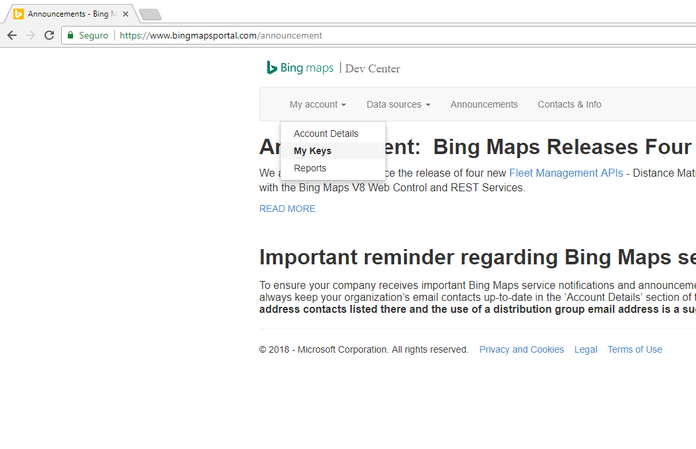

* 1. On the next screen, choose a name for the application (*Application Name*), choose the option *Basic* on the *Key type* field and option *Private Windows App* on the *Application type* field. Finish clicking on the button *Create*.

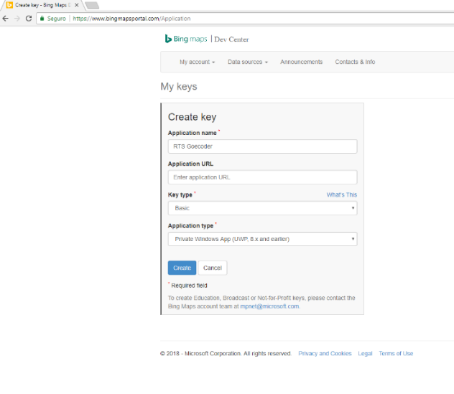

* 1. Copy the *Key* and save. It will be necessary later for the Geocoder.

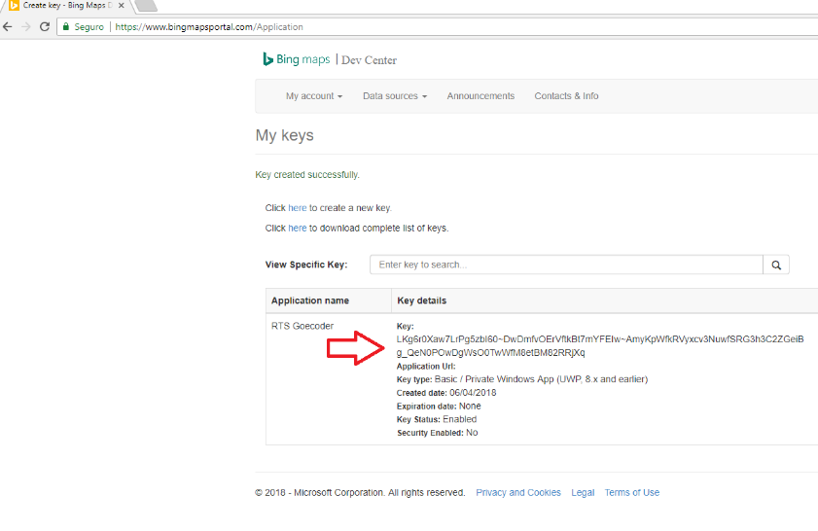

* 1. For Google Key, an account is needed to access the platform. Access the following link and select the options *Maps* and *Places*. <https://cloud.google.com/maps-platform/?_ga=2.27469433.412543613.1528139207-182559285.1528139207#get-started>

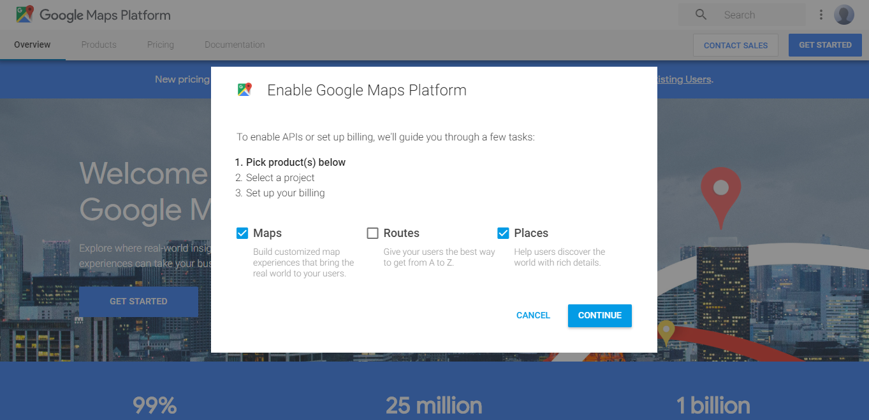

* 1. On the next screen choose the option “Create billing account”

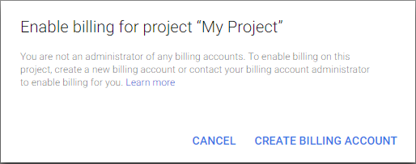

* 1. Select the country and agree to the Google terms.

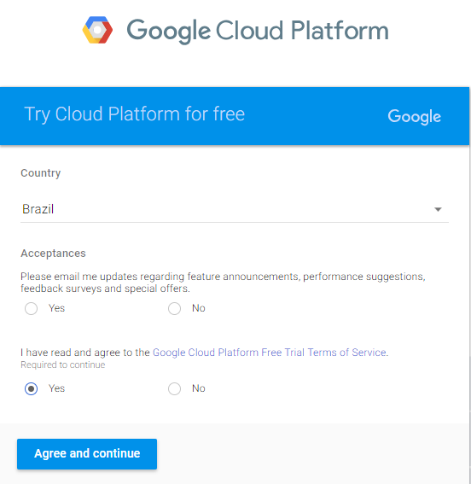

* 1. Fill the registration form.
  2. Activate the Google API, copy the Google *Key* and save. It will also necessary later for the Geocoder.

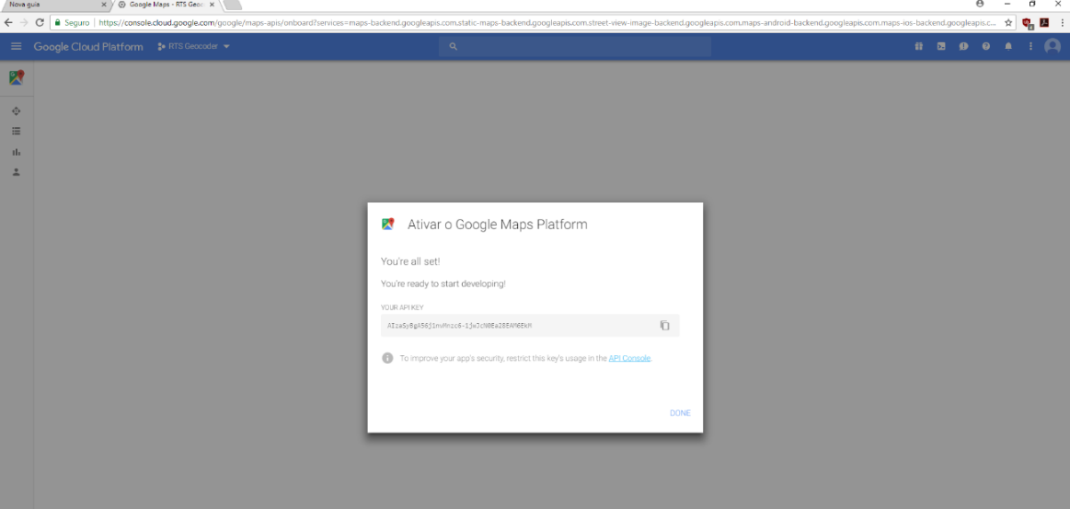

1. The Geocoder is not installed in the computer, but it must be executed on the same computer that Roadnet is installed. As a pattern, the ODBC 32-bit is pointed to the Roadnet server database with the name ROADNETDATA. If the configurations are different, contact you IT.

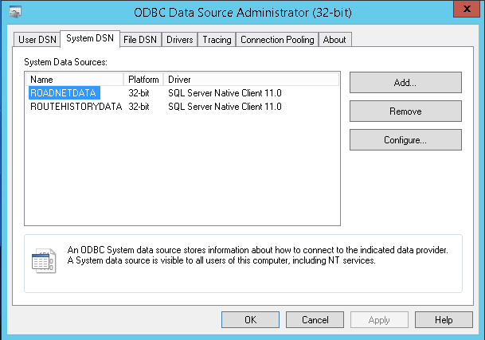

1. Open the Geocoder. If the following error message pops, choose YES and install the .NET Framework.

